Bone Fracture Detection using Machine Learning

Dodda Venkata Reddy1, Badri Venkata Durga Praveen 2, Elchuri Rushi Naga Manikanta 3, Thota Sumanth 4

1 Assistant Professor, 2, 3 & 4 Student

1 [doddavenkatareddy@gmail.com](mailto:doddavenkatareddy@gmail.com), 2 [badrivdpraveen5@gmail.com](mailto:badrivdpraveen5@gmail.com), 3 [elchurirushi@gmail.com](mailto:elchurirushi@gmail.com), 4 [sumanththota2003@gmail.com](mailto:sumanththota2003@gmail.com)

Department of Computer Science and Engineering,

Narasaraopeta Engineering College, Narasaraopet, Andhra Pradesh, India

*Abstract*— In today's interconnected world, computers play a pivotal role across diverse domains, revolutionizing aspects such as banking, online commerce, communication, education, research, and healthcare. To enhance medical practices and patient care, innovative technological solutions have emerged. Traditional X-ray scanners often produce indistinct images, posing a risk of misdiagnosis for bone fractures. A comprehensive approach that includes steps like pre-processing the x-ray image, bone edge finding, feature extraction, and machine learning classifiers has been designed to handle this difficulty. The algorithms accuracy evaluations range from 0.62 to 0.94. Remarkably, SVM stands out with the highest accuracy, surpassing most comparable studies. This statistical finding underscores the potential of SVM in fracture detection, reflecting advancements in medical imaging analysis.

Keywords— Computers, Interconnected world, medical practices, Technological solutions, X-ray scanners, Bone fractures, Diagnostic process, Machine learning classifiers, Accuracy assessment, medical imaging analysis.

# Introduction

The 206 bones that make up the human body vary in size, complexity, and form, with wrist fractures being common [1]. Machine learning in medical imaging has gained attention for aiding accurate diagnosis and treatment planning. This has helped doctors diagnose patients more precisely and create treatment programs that work best for them [2]. Because bone fractures can occur to anybody at any time and are becoming more common worldwide, especially in wealthy countries, prompt diagnosis and treatment are essential [3].

X-rays, supported by the DICOM standard, are widely used for diagnosing bone fractures. Because they are quick, inexpensive, and easy to use, X-rays are one of the most common diagnostic tools for bone fractures [4-5]. Medical imaging has developed quickly since Wilhelm Roentgen discovered X-rays in 1895, and it is now an essential part of contemporary diagnosis. Digital X-ray imaging equipment are widely used in many different medical settings due to their portability and advances in computerized image processing [4]. Medical data analytics relies heavily on machine learning, which calls for complex algorithms to analyse and spot anomalies in skeleton-related medical pictures [5].

Considering the variety of origins of bone fractures, timely and precise diagnosis is essential for successful treatment. X-rays are usually ordered by physicians or radiologists when a fracture is suspected in order to determine its kind and severity [6 Manual examination and conventional X-ray techniques are used to find fracture but they are laborious and error-prone. By using computer vision technologies, X-ray pictures can be screened for anomalies that could indicate a fracture and notify the treating physician [7]. With unacceptable faults coming from depending just on human specialists, the idea of automated diagnostic tools has gained momentum. Numerous techniques, such as preprocessing and fracture recognition, have been put forth for identifying and categorizing fractures to the leg bones seen in X-rays [8–9].

Identification of the fracture type is essential for choosing the best course of action and prognosis. More than twenty percent of hospital admissions are due to tibia fractures, which are the most prevalent type of bone fracture [10]. This puts a great deal of pressure on physicians, who have to review a large number of X-ray pictures every day. Over a century has passed since the invention of X-ray technology, but it's still the principal way to make a diagnostic [11]. Nonetheless, radiographic interpretation is frequently carried out without having access to knowledgeable colleagues for advice [12–13].

A fracture's best course of treatment and prognosis depend on its accurate classification into recognized categories. In this sense, computer-aided diagnostic (CAD) systems have potential to help physicians. Prior research on fracture categorization and identification has led to substantial use of traditional machine learning methodologies, such as preprocessing, feature extraction, and classification; nevertheless, machine learning algorithms have recently spurred breakthroughs in this field [14].

Using a variety of preprocessing techniques, the first stage of the process entails noise removal and early picture processing. The difficult work of extracting distinguishing features from the photos is what comes next. Finally, a number of machine learning classification methods are used, and they are assessed through the use of conventional testing protocols.

# Related works

A summary of the literature on Bone fracture identification and categorization is provided throughout this section, covering both traditional and novel approaches.

A meta classifier that combined neural network (NN) and decision tree (DT) methodologies was exhibited by E. Mysuru et al. [6] and showed enhanced accuracy, reaching 85%. Segmentation, detection of edges, initial processing, and extraction of features are some of the distinct steps in the process that result in the classification of bone into fractured and non-fractured categories.

Support Vector Machine (SVM) learning approach by , D. Prakash et al. [11] presented a method for long bone fracture classification that achieved a 78% detection rate for transverse and oblique fractures.

An approach by A. Rajput et al. [14] employs preprocessing, feature extraction, and SVM classification, achieving an accuracy of 84.7% in fracture detection.

N. Singh et al. [15] proved the efficacy of the Canny Edge Detection algorithm for edge detection in X-ray pictures, offering improved image analysis through intensity discontinuities.

A CNN technique using Spatial Fuzzy C-Means (SFCM) was presented by Y. Prathyusha et al. [16]. To reach a 78% accuracy and preprocessing stages.

Using local Shannon entropy computation, a hybrid technique reported by E. Sorantin et al. [17] successfully detects pediatric ulna and radius fractures with an astounding 91% accuracy rate.

J.D. Obando et al. [18] proposed an X-ray image processing technique, with preprocessing enhancements such as CLAHE, achieving an 80% accuracy.

A deep neural network model was created by S. Rathor et al. [19] to differentiate between healthy and fractured bone. After correcting for overfitting using data augmentation, the model achieved a 92.44% classification accuracy.

Finally, R. Madupu et al. [20] compared their proposed method with Harris corner detection, demonstrating the superior accuracy (91%) of BPNN paired with cautious smoothing and perceptive edge detection for automated bone fracture identification.

# Methods

Dataset collection, preprocessing, edge detection, key feature finding, and lastly classification are the five primary modules that make up the bone fracture detection system. Figure 1 outlines the stages of the suggested procedure for locating fractured bones in X - ray scans.

## Pre-processing

By addressing noise, inconsistencies, and incompleteness, preprocessing is essential to improving the image's accuracy. The initial step involves converting the image from RGB to shades of grey format and then Gaussian filter used for cancellation of noise.

1. Noise Cancellation:

Noise is the word for extraneous pixels that degrade the general quality of the picture. Noise can manifest in various forms, with "salt and pepper" noise being common in X-ray images. This kind of noise shows up in the image as sporadic bright and dark patches, typically resulting from capture or transmission malfunctions.

Fig. 1: Architecture

Pixels that are significantly different from their neighbors are replaced with the median value, enhancing image quality.

This noise cancellation step is crucial for improving the accuracy of subsequent analysis in the bone fracture detection system.

2. Enhancement of Contrast:

A digital image processing method called adaptive histogram equalization is used to improve image contrast. In contrast to traditional histogram equalization, the adaptive method improves contrast on a local level. It has been shown that this technique works well to increase the contrast of medical X-ray pictures.

## Canny Edge Detection

A popular method for obtaining useful structural information from a variety of objects in vision systems is called "canny edge detection," which significantly lowers the volume of data that needs to be analyzed. This technique examines the image's fluctuating intensity over time. A few examples of the variables that affect edge detection quality are noise levels, edge density, and the presence of objects with similar intensities.

It has been found in this study that the Canny edge detection research can be modified led to the best results by adding an adaptive histogram to improve contrast.

## Feature Extraction

A crucial move in image processing, especially when it comes to bone fracture identification, is feature extraction. For the purpose of extracting textural qualities like contrast, correlation, homogeneity, energy, and dissimilarity, the Gray-Level Co-occurrence Matrix (GLCM) technique is a useful tool.

These traits are important for identifying fractures because they help distinguish minute variations in bone structure. The following formulas can be used to determine each of these textural qualities using the GLCM method:

1. Contrast:

Contrast is a metric used to quantify the variation in strength between pixels next to each other in an image.

(1)

Greater contrast values represent a more noticeable variance in the image by indicating higher differences in intensity levels between neighboring pixels.

2. Correlation:

The degree of linear dependence between the image's pixel brightness is evaluated using correlation.

(2)

A strong linear relationship between pixel intensities is shown by a correlation value near 1, which points to a more equal distribution of intensities in the image.

3. Homogeneity:

The degree to which pixel intensities are near the GLCM diagonal is measured by homogeneity.

(3)

Greater homogeneity values imply a smoother texture in the image by increasing the likelihood of pixel pairs with comparable intensities.

4. Energy:

The uniformity of pixel intensities in an image is quantified by energy, which is sometimes referred to as uniformity or angular second moment.

(4)

A homogenous texture is suggested by higher energy levels, which show a more uniform distribution of pixel intensities in the image.

5. Dissimilarity:

The average difference in intensity between pairs of pixels in the image is measured by dissimilarity.

(5)

Greater intensity differences between nearby pixels are indicated by higher dissimilarity scores, which may imply a more varied texture in the image.

These textural characteristics offer important information on the spatial correlations between pixel intensities, which helps with the identification of fractures in X-ray pictures and the efficient characterization of bone structures.

# Results

The collection of X-ray pictures included 70 non-broken and 120 fractured wrist bone photos that were taken from Kaggle.

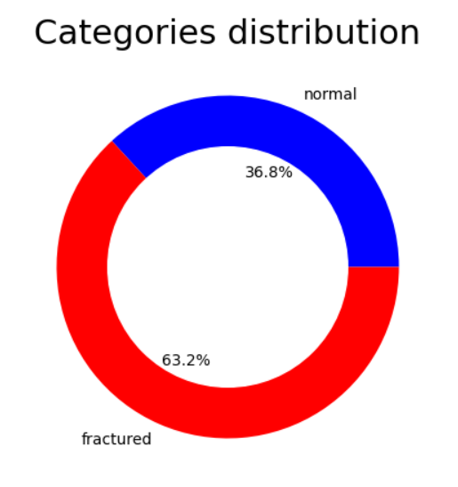

Fig. 2. Dataset distribution

After applying the methods described in the preceding sections to the dataset, the following outcomes were obtained:

## Pre-processing

Fig. 2 depicts the initial X - ray image prior to preprocessing. The X-ray image after a Gaussian filter is applied to remove noise is shown in Fig. 3. Fig. 4 showcases the X-ray image after enhancement and adaptive histogram equalization. Fig. 5 showcases the detection of bone structures and edges using the Canny edge detection algorithm.

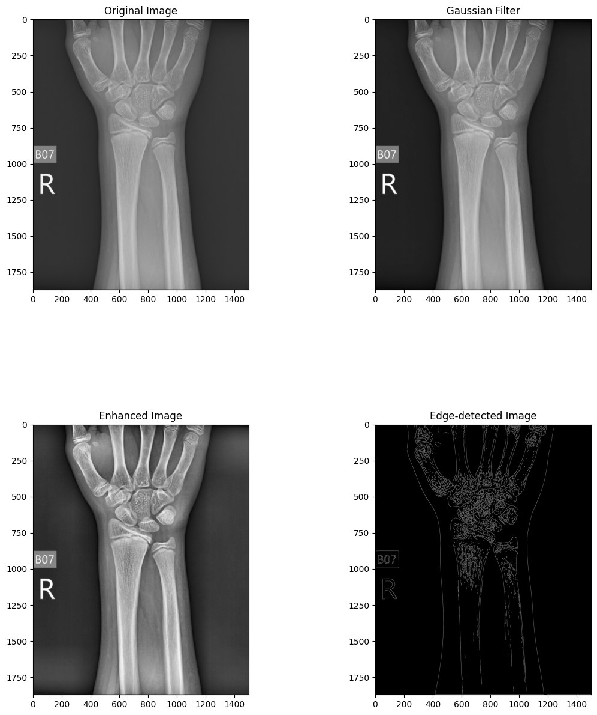

Fig. *3*. X - ray image original



Fig. *4*. X - ray after gaussian filter



Fig. *5*. X - ray after enhancing



Fig. *6*. X-ray after edge detection.

## Feature Extraction

140 characteristics were extracted per image using GLCM, which produced five attributes for four distances and seven angles. To maximize accuracy, several combinations of characteristics, distances, and angles were tried while using Python programs to extract GLCM features.

Fig. 7 displays an example of extracted GLCM features for five photos with angle = 90° and distance = 1.

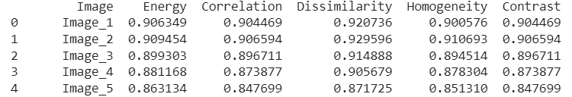

Fig. ***7***. GLCM features for 5 random images

## Classification

Using random selection, 80% of the dataset was implemented to learn and 20% for validation. The model was learned and tested using a variety of machine learning classifiers, such as Support Vector Machine (SVM), Naive Bayes, KNN, Random Forest, and Decision Tree.

1. SVM:

For problems involving regression and classification, Support Vector Machine (SVM) is a supervised machine learning technique. It works especially effectively for classifying complicated datasets with ill-defined class boundaries.

The SVM classifier's ROC curve is shown in Fig. 8. The confusion matrix of the SVM classifier is shown in Fig. 9, where the majority of the images are properly predicted.

2. Random Forest:

Random Forest is a popular and adaptable ensemble learning technique for tasks involving regression and classification. In order to function, it builds a large number of decision trees during training and outputs the class that represents the mean prediction (regression) or mode of the classes (classification) of the individual trees.

Fig. 10 shows the Random Forest classifier's ROC curve. Fig. 11 illustrates the confusion matrix of the random forest classifier, demonstrating that certain genuine fragmented images are anticipated to be non-fractured.

3. KNN:

A straightforward and understandable supervised machine learning approach for classification and regression problems is K-Nearest Neighbors (KNN). Predictions are made using this non-parametric approach depending on how closely input data points resemble training samples.

The KNN classifier's ROC curve is shown in Fig. 12. The KNN classifier's confusion matrix, shown in Fig. 13, demonstrates that the majority of real fragmented images are predicted to be non-fractured.

4. Decision Tree:

For both regression and classification applications, decision trees are popular and adaptable supervised machine learning methods. Because they are easy to understand, can handle both categorical and numerical data, and are simple to use, they are very popular.

The decision tree classifier's ROC curve is shown in Fig. 14. Fig. 15 illustrates the decision tree classifier's confusion matrix, demonstrating how some actual fragmented images are predicted to be non-fractured.

5. Gaussian Naive Bayes:

The Naive Bayes algorithm, a straightforward probabilistic classifier based on applying Bayes' theorem with strong (naive) independence assumptions across the features, is a form known as Gaussian Naive Bayes (GNB). The Gaussian distribution and continuity of the features are assumed by GNB.

Fig. 16 shows the Naive Bayes classifier's ROC curve. Fig. 17 illustrates the confusion matrix of the naïve bayes classifier, demonstrating that certain genuine, non-fractured images are anticipated to be fractured.

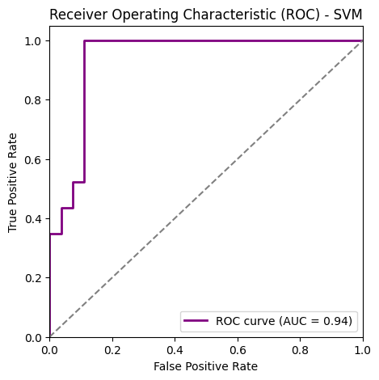

Fig. *8*. ROC Curve of SVM Classifier

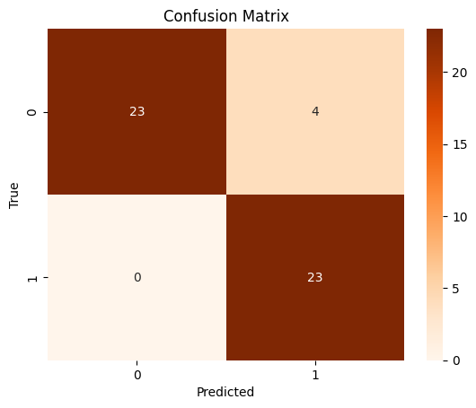

Fig.*9*. Confusion matrix of SVM classifier

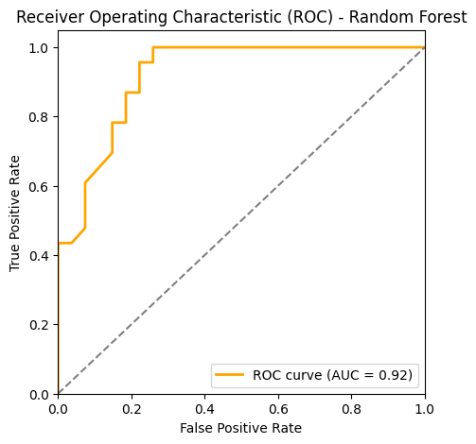

Fig. *10*. ROC Curve of Random Forest Classifier

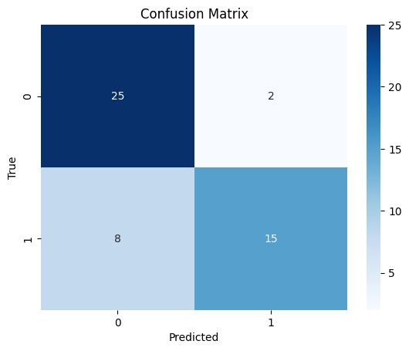

Fig. *11*. Confusion matrix of Random Forest classifier

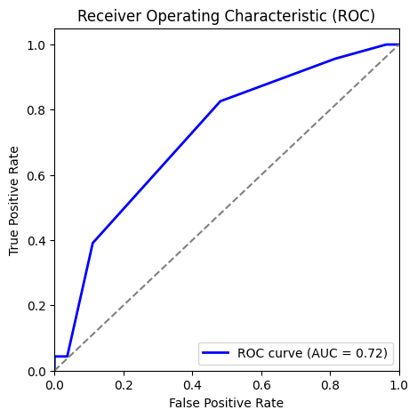

Fig. *12*. ROC Curve of KNN Classifier

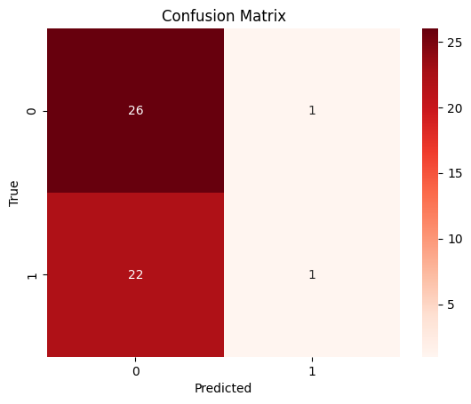

Fig. *13*. Confusion matrix of KNN classifier

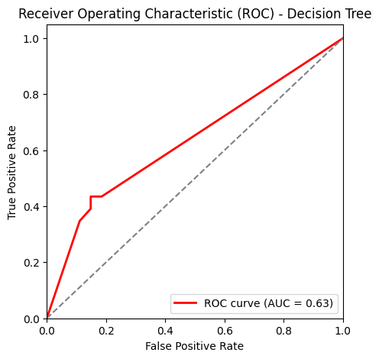

Fig. 14 ROC Curve of Decision Tree Classifier

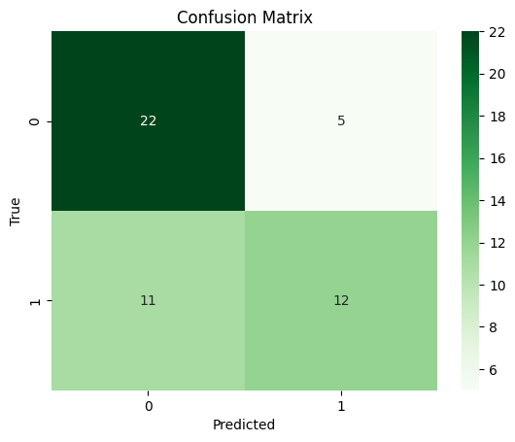

Fig. *15*. Confusion matrix of Decision Tree classifier

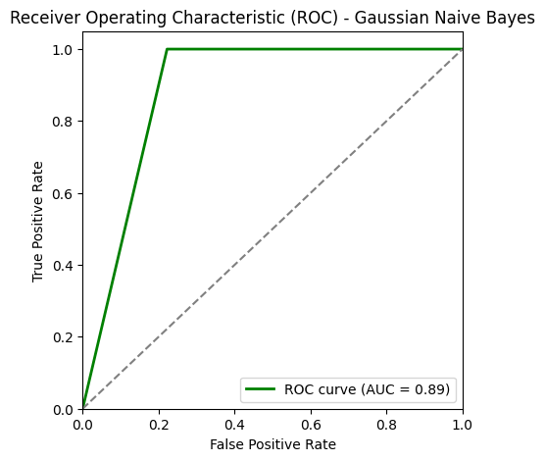

Fig. *16*. ROC Curve of Naive Bayes Classifier

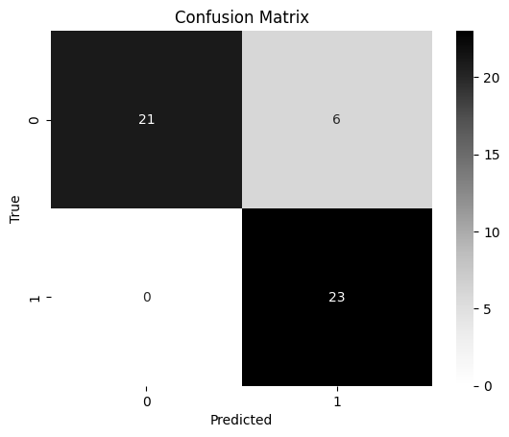

Fig. *17*. Confusion matrix of Naïve Bayes classifier

Precision, Recall, and accuracy were assessed together with True Positive (TP), True Negative (TN), False Positive (FP), and False Negative (FN) results.

(7)

(8)

(9)

Table 1 displays a comparison of the efficacy of various machine learning methods. Accuracy of Naïve bayes is 0.88, Decision tree is 0.76, Random Forest is 0.62, KNN is 0.78, and SVM is 0.94 were attained.

Table 2 provides a comparison with other studies reviewed in this research, showcasing the effectiveness of the proposed system.

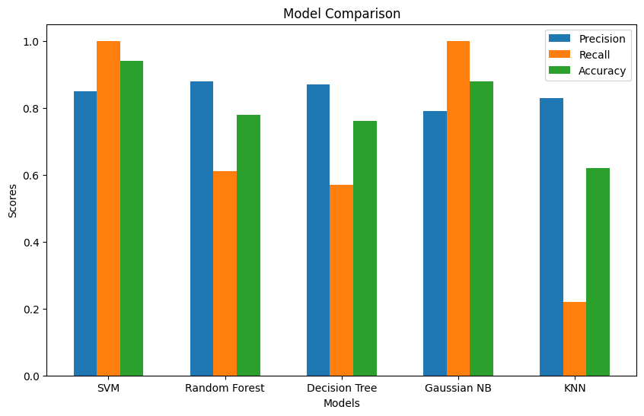

Fig. *18*. Evaluation of different ML models performances

Table 1: Accuracy, Precision and Recall

|  |  |  |  |
| --- | --- | --- | --- |
| Model | Precision | Recall | Accuracy |
| SVM | 0.85 | 1.0 | 0.94 |
| Random Forest | 0.88 | 0.61 | 0.78 |
| Decision Tree | 0.87 | 0.57 | 0.76 |
| Gaussian NB | 0.79 | 1.0 | 0.88 |
| KNN | 0.83 | 0.22 | 0.62 |

Table 2: Comparing this paper to others

|  |  |  |  |
| --- | --- | --- | --- |
| Citation | Year | Strategy | Accuracy |
| [6] | 2015 | Decision Tree | 0.85 |
| [11] | 2017 | SVM | 0.78 |
| [14] | 2017 | SVM | 0.84 |
| [16] | 2019 | CNN with SFCM | 0.78 |
| [18] | 2019 | SVM with CLACHE | 0.80 |
| [19] | 2020 | CNN | 0.92 |
| [20] | 2020 | Back propagation Neural Network | 0.91 |
| **Current** | **2024** | **SVM** | **0.94** |

## User Interface

In our project, the user interface (UI) is crafted with simplicity and functionality in mind, ensuring a smooth and intuitive experience for users interacting with the medical image classification system.

The UI features a straightforward design, guiding users through the process of uploading an X-ray image for fracture detection which shown in Fig. 20. Users begin by clicking on the "New Predictions" button as shown in Fig. 19, initiating the prediction process. They then upload the X-ray image like in Fig. 20 and click "Detect" to trigger the classification task. The UI presents the prediction results clearly, indicating whether the X-ray is fractured or not like in Fig. 21 & 22.

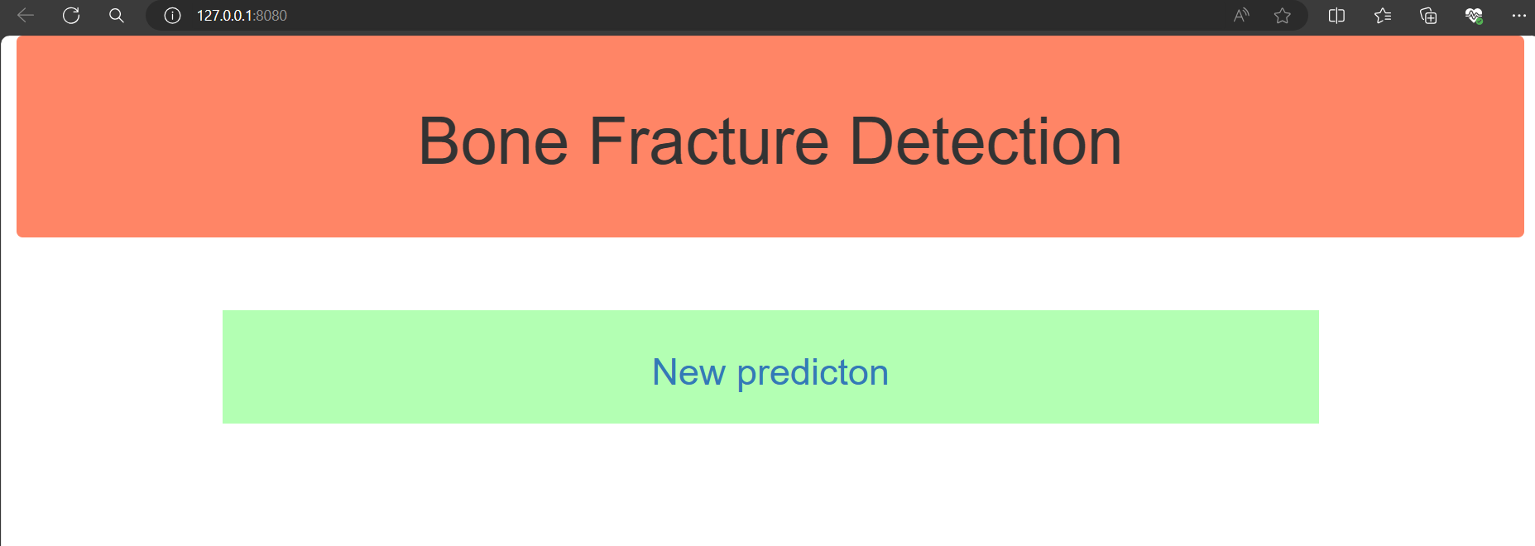

Fig. *19*. Home Page

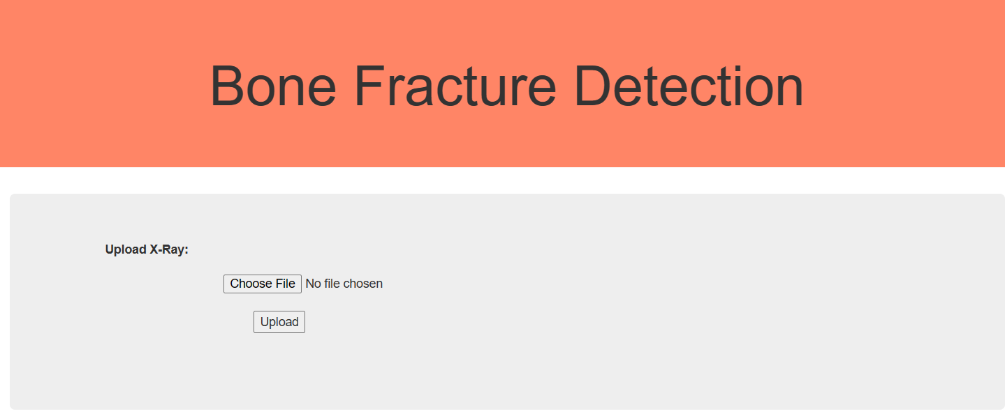

Fig. *20*. X-ray upload

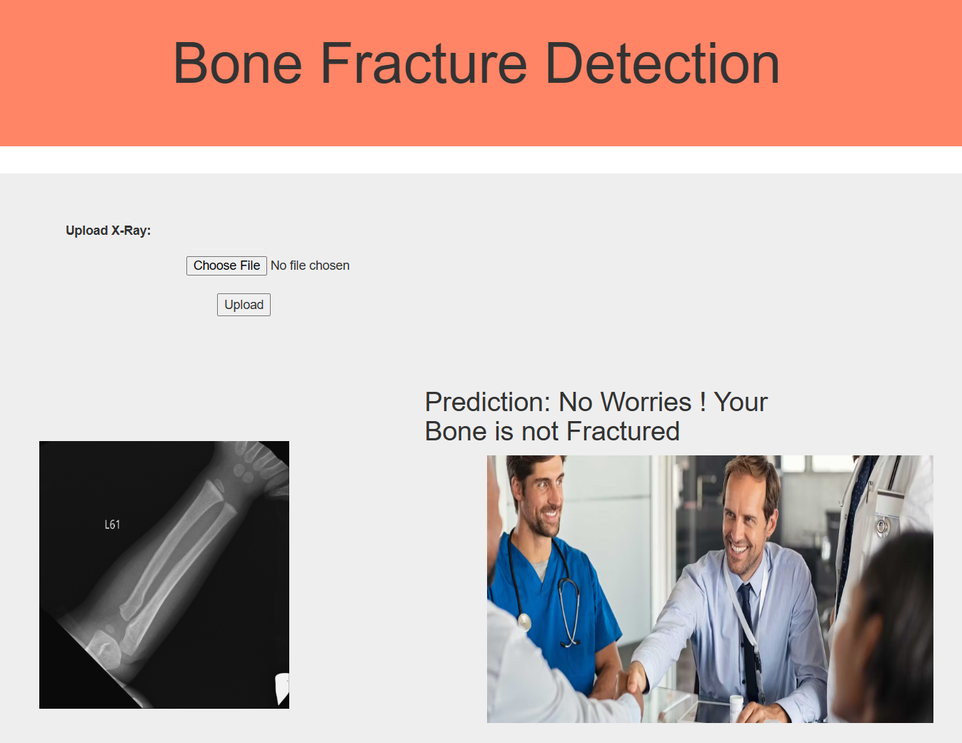

Fig. *21*. Classification result if bone is not fractured

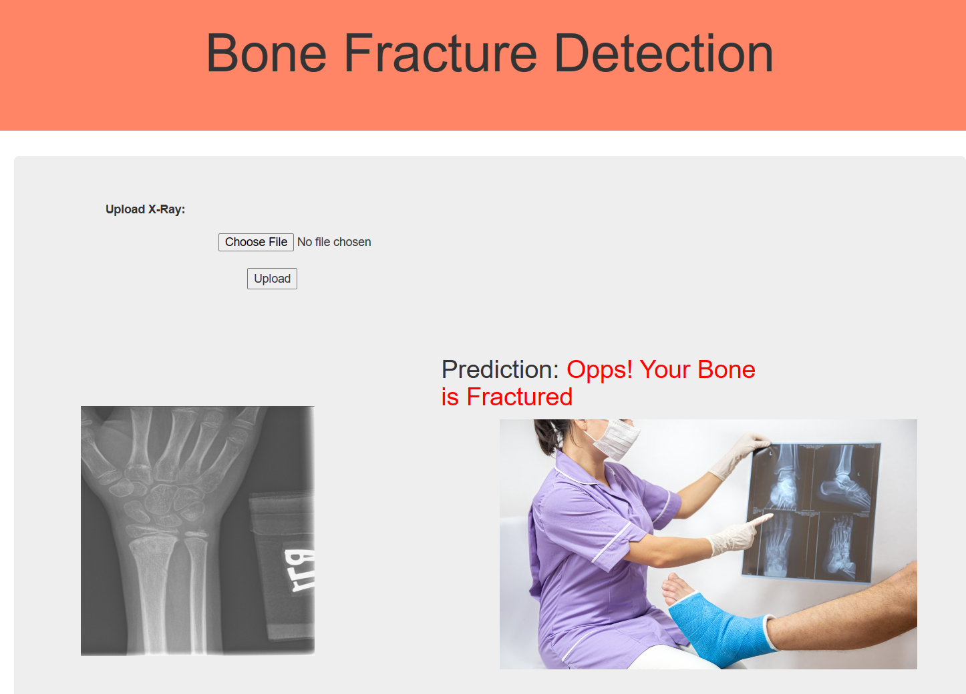

Fig. *22.* Classification result if bone is fractured

# Conclusion

The main target of this study was to produce a tool that would assist medical professionals quickly and effectively diagnose whether or not a patient had a fractured wrist bone. This study describes an automated method for classifying and identifying bone fractures from X-ray images using machine learning.

Both fractured and intact bones, along with their corresponding X-ray images, were utilized in the experiment. With the increasing prevalence of bone fractures globally, the ability to detect even minor fractures holds significant value in medical practice. Thus, the proposed technique offers the capability to distinguish broken bones versus whole ones.

The GLCM is utilized for obtaining various characteristics from X-ray scans in order to machine learning algorithms can use them for classification, however the Canny edge detection is an asset for edge detection. A multitude of machine learning techniques and methods for analyzing images are included into the system with the express purpose of identifying lower wrist bone fractures.

Throughout the research, various machine learning strategies including Decision Tree, Naive Bayes, KNN, SVM, and Random Forest demonstrated accuracies ranging from 0.66 to 0.94. Notably, SVM exhibited its effectiveness in fracture detection and classification more accurate.

In conclusion, the developed system represents a promising approach to enhance the efficiency and accuracy of diagnosing wrist bone fractures, ultimately contributing to improved patient care and outcomes in medical practice.

##### References

1. F. Majeed, S. Adnan W. Abbas & M. Javid,” Lower Leg Bone Fracture Detection and Classification Using Faster RCNN for X-Rays Images”, IEEE (2020).
2. A. Al-Ghaithi & S. Al Maskari,” Artificial intelligence application in bone fracture detection”, Journal of Musculoskeletal Surgery and Research (2021).
3. C. McCollough, J. Bushberg, G. Fletcher & L. Eckel, "Answers to common questions about the use and safety of CT scans", Elsevier(2015).
4. P. Cephas & H. Hepzibah, "A robust approach for detection of the type of fracture from X-ray images", International Journal of Advanced Research in Computer and Communication Engineering (2015).
5. Sami H. Ismael, Shahab W. Kareem & Firas H. Almukhta, "Medical Image Classification Using Different Machine Learning Algorithms", AL-Rafidain Journal of Computer Sciences and Mathematics (2020).
6. S. College, E. Mysuru & R. Raman, "Detection of bone fracture using image processing methods", International Journal of Computer Applications (2015).
7. S.W. Kareem, "An evaluation of algorithms for classifying Leukocytes images", IEEE(2021).
8. B. Czerniak, "Dorfman and Czerniak’s Bone Tumors E-Book", Elsevier(2015).
9. Shahab Wahhab, Kareemab Roojwan ScHawezia & Farah Sami Khoshabaa, "A Comparison of Automated Classification Techniques for Image Processing in Video Internet of Things", Elsevier (2022).
10. N. Umadevi & D. GeethaJakshmi, "Multiple classification system for fracture detection in human bone x-ray images", IEEE (2012).
11. A. Vishnu, D. Prakash & S. Sharmila, "Detection and classification of long bone fractures", International Journal of Applied Engineering Research (2017).
12. L. Tanzi, E. Vezzetti, R. Moreno & S. Moos, "X-Ray Bone Fracture Classification Using Deep Learning: A Baseline for Designing a Reliable Approach", MDPI (2020).
13. Hersh A. Muhamad, Shahab Wahhab Kareem & Amin Salih Mohammed, "A deep learning method for detecting Leukemia in real images", MDPI (2022).
14. A. Tripathi, A. Upadhyay & A. Rajput, "Automatic detection of fracture in femur bones using image processing", Elsevier (2017).
15. N. Johari & N. Singh, "Bone fracture detection using edge detection technique", Springer Link(2017).
16. S.S. Sinthura, Y. Prathyusha, K. Harini, Y. Pranusha & B. Poojitha, "Bone fracture detection system using CNN algorithm", IEEE (2019).
17. F. Hrzic, I. Stajduhar, S. Tschauner, E. Sorantin & J. Lerga, "Local-entropy based approach for X-ray image segmentation and fracture detection", MDPI (2019).
18. E. Castro-Gutierrez, L. Estacio-Cerquin, J. Gallegos-Guillen & J.D. Obando, "Detection of Acetabulum Fractures Using X-Ray Imaging and Processing Methods Focused on Noisy Images", IEEE (2019).
19. D. Yadav & S. Rathor, "Bone fracture detection and classification using deep learning approach", IEEE(2020).
20. S. Karimunnisa, R. Madupu & P. Savarapu, "Detection of Bone Fractures Automatically with Enhanced Performance with Better Combination of Filtering and Neural Networks", IEEE(2020).